Problem Statement – CampusGPT

CampusGPT is an AI-powered academic assistant developed to address the limitations of traditional learning support systems that lack contextual understanding, intelligent document retrieval, and personalized student interaction. Existing chatbots often fail to retain conversational context, provide accurate answers from academic materials, or support semantic understanding of uploaded documents. To solve this, the project implements a modern Retrieval-Augmented Generation (RAG)
UI References
ChatGPT Style
Clean
Professional
Easy to build
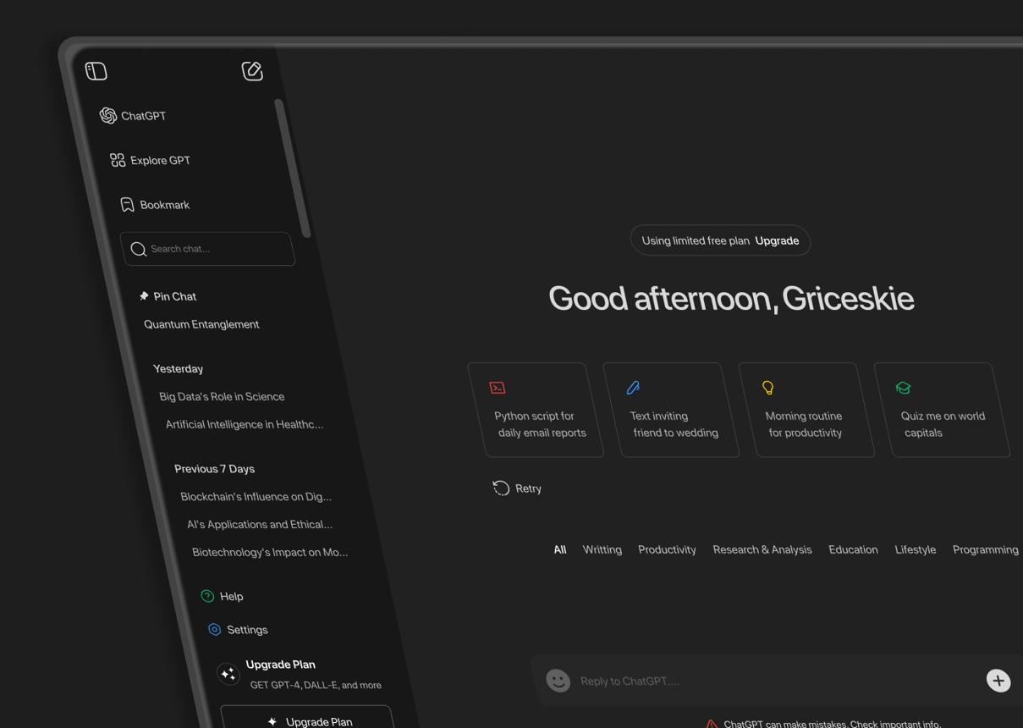

Features:
- sidebar chats
- smooth bubbles
- typing effect
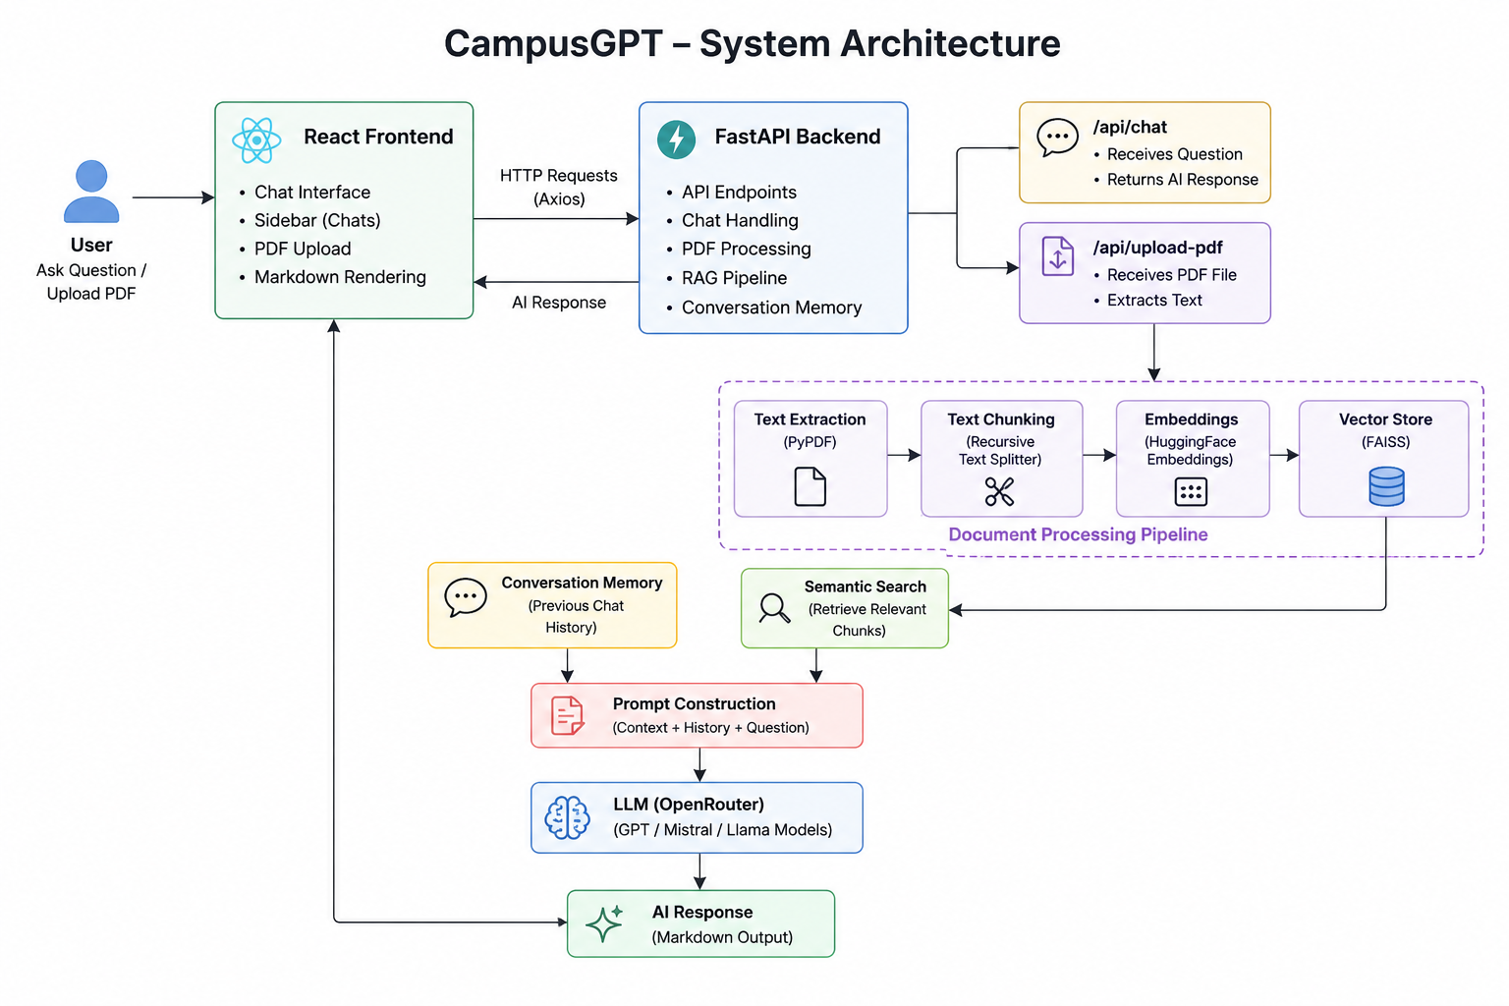
ARCHITECTURE:

